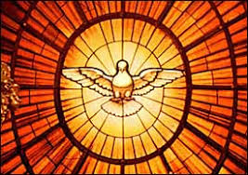
ORDER OF SERVICE

6th Sunday of Easter – May 17th, 2020 - 8:30 am

Prelude “Come Down, O Love Divine” – R. Vaughan Williams/Jan Bender

Welcome

Confession and Forgiveness

Gathering Hymn “Come Down, O Love Divine!” ELW #804

Greeting
Kyrie (setting three) p. 138

Hymn of Praise p.139 Glory to God….

Prayer of the Day

First Reading: Acts 17:22-31

Second Reading: 1 Peter 3:13-22

Gospel Acclamation:

Gospel: John 14: 15-21 (The Holy Gospel according to John. Glory to you, O Lord. )

(The Gospel of the Lord. Praise to you, O Christ.)

Sermon: Pastor Nate Toso

Hymn of the Day “What Wondrous Love Is This” ELW #666

Apostle’s Creed

Prayers of the People (Lord, in your mercy. Hear our prayer.)

Peace

Offering Solo – “All Things Bright and Beautiful” – John Rutter Soloist – Mary Gregory

Offering Prayer

Lord’s Prayer and Communion Hymn “Jesus Loves Me!” ELW #595

Communion

Post-communion prayer and blessing

Announcements

Sending Song “Love Divine, All Loves Excelling!” ELW #631

Dismissal (Go in peace. Serve the Lord. Thanks be to God.)

Postlude “Toccata in E Minor” - Johann Pachelbel

