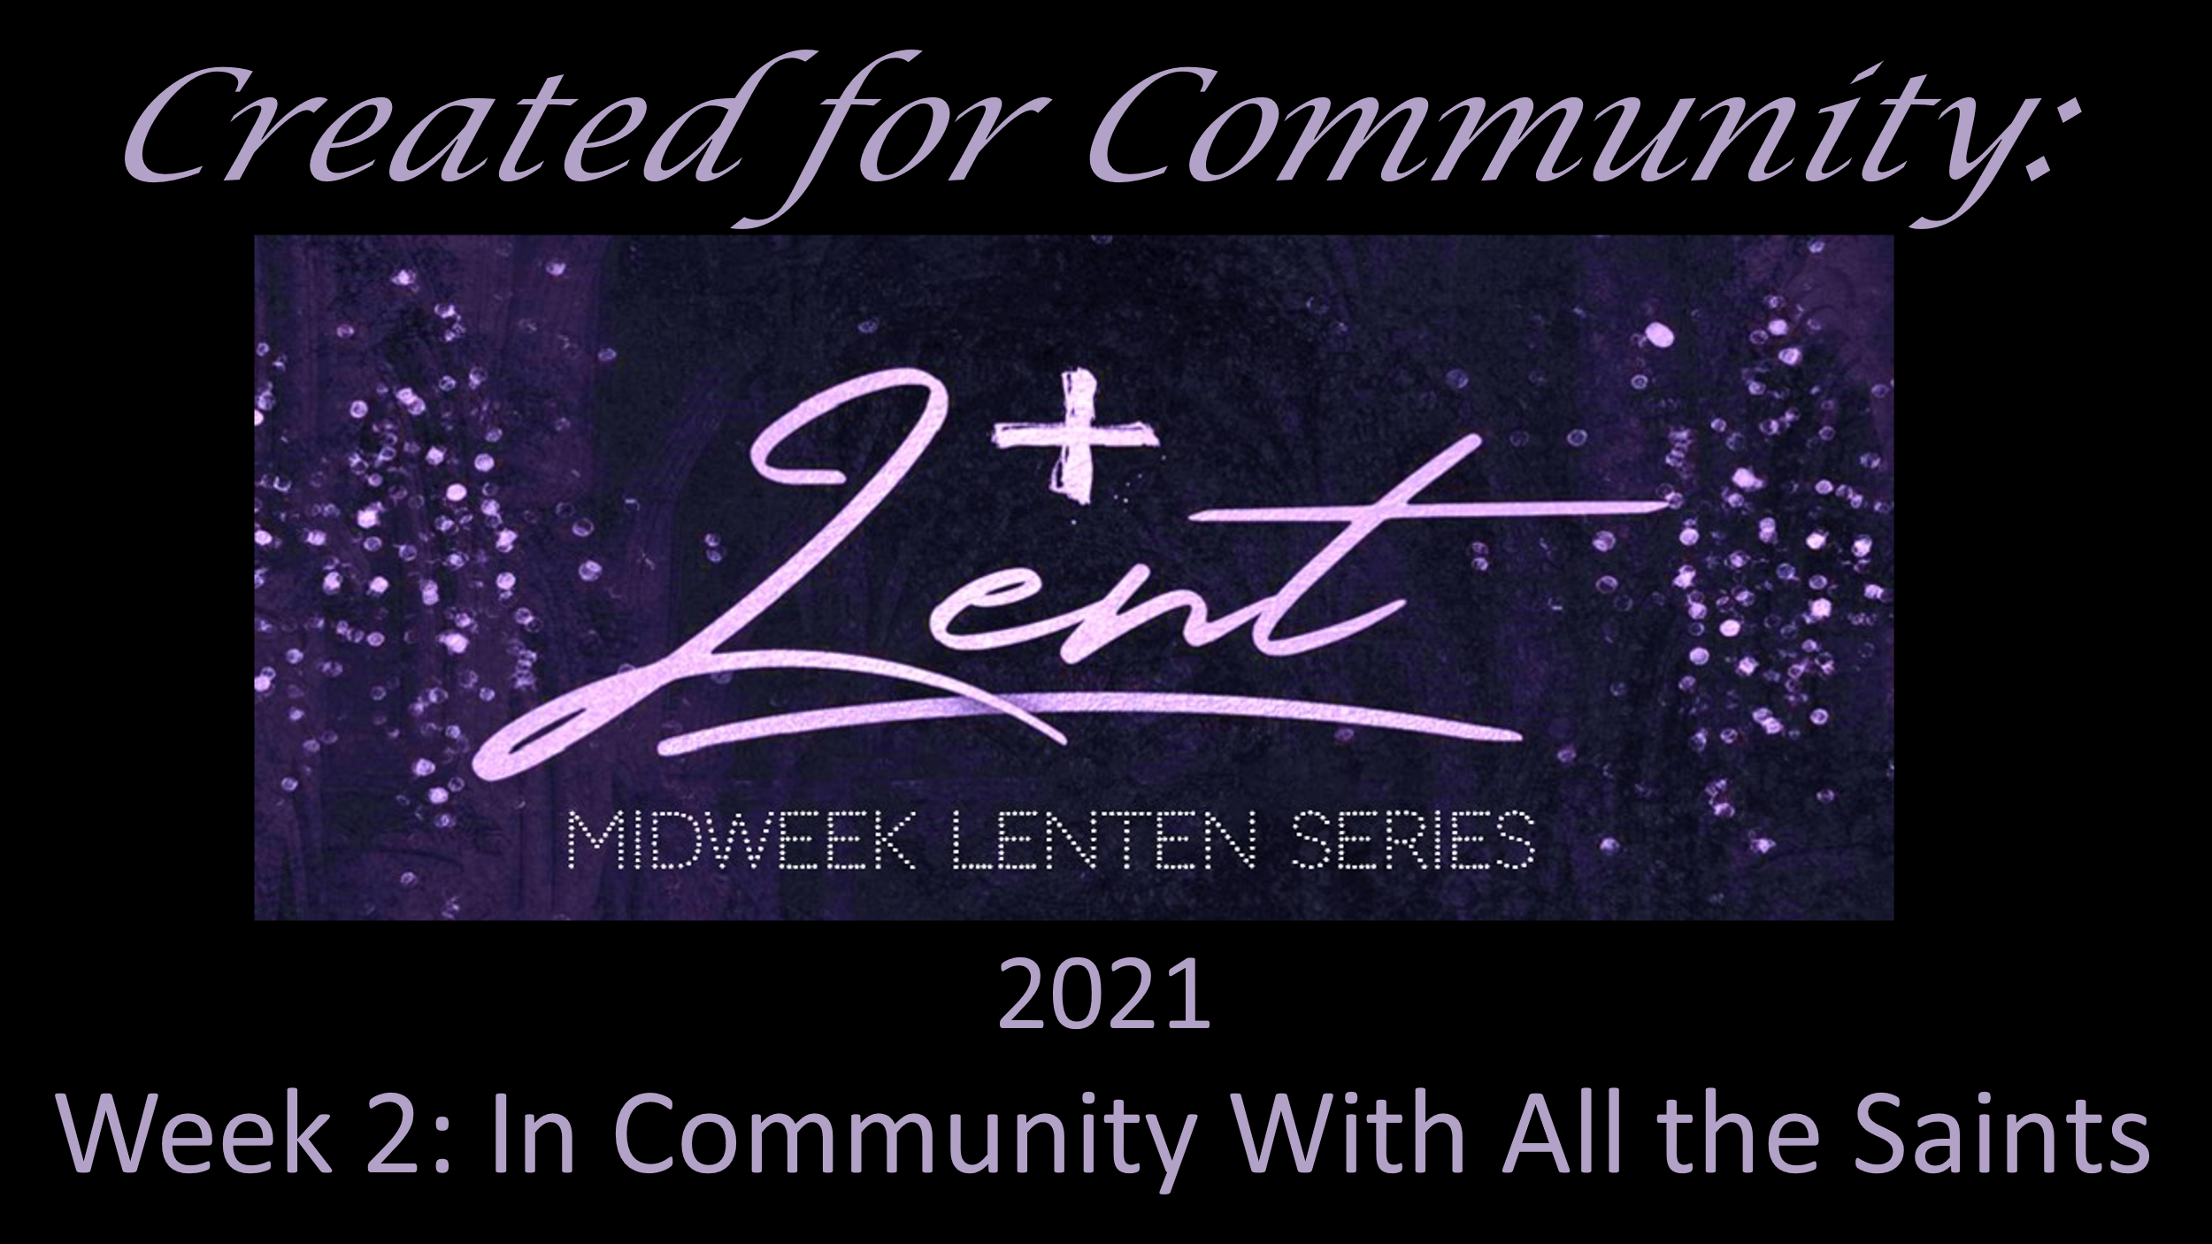
ORDER OF SERVICE

Midweek Lenten Series 2021 – Week 2
In Community with All the Saints

March 3, 2021

Welcome - Organist – Marilyn Wahlstrom Soloist – Mary Gregory

Gathering Song - For By Grace, You Have Been Saved – ELW 598
Prayer

Scripture Reading: Mark 9:2-8 – Jesus is in conversation with those who have gone before him

Introduction to Centering Prayer

Centering Prayer

Sung Response - We Walk by Faith – ELW 635

Prayers

Blessing

Sending Song - All Praise to Thee, My God, This Night – ELW 565

Dismissal

